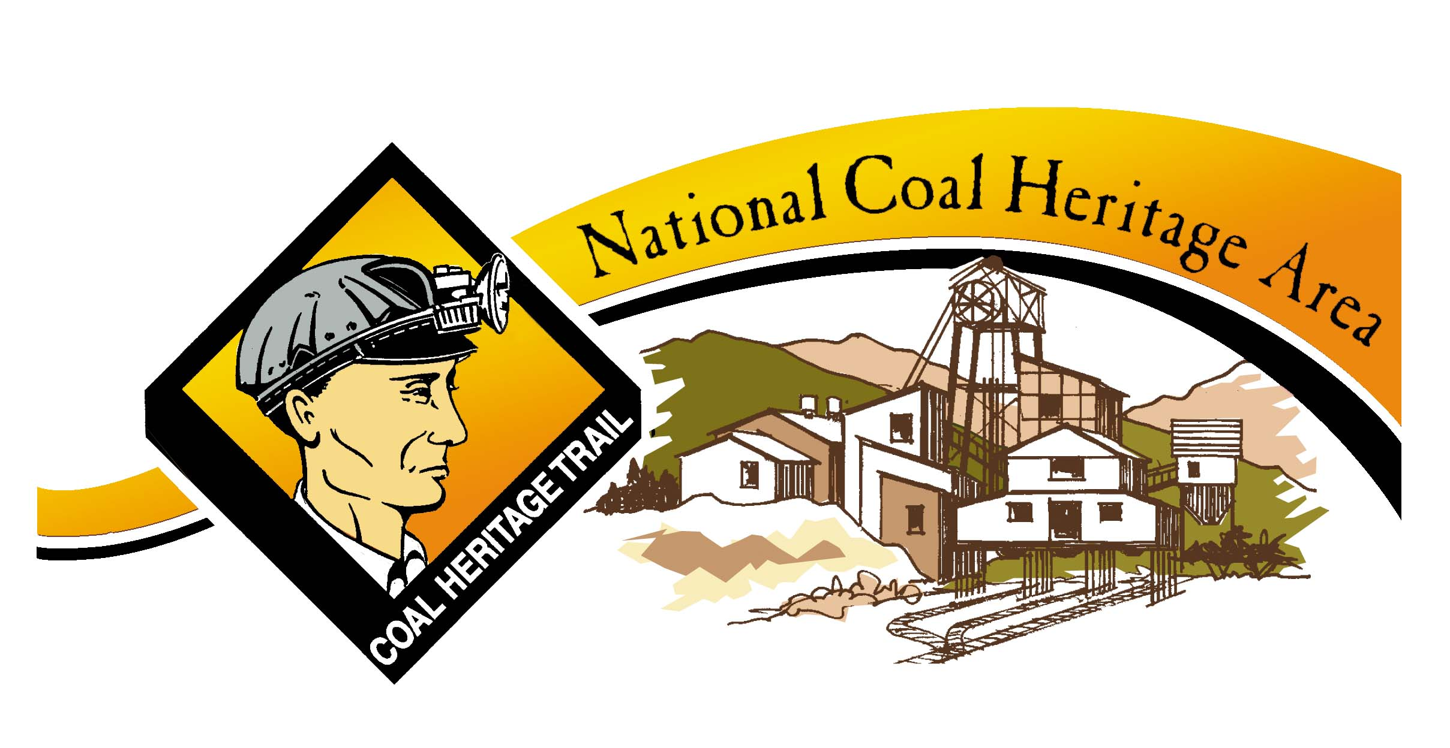

The 2013 Coal Heritage Highway Authority and National Coal Heritage Area
Achievement Awards

The Coal Heritage Highway Authority and National Coal Heritage Area would like to recognize outstanding achievement by communities, organizations and individuals in preserving and promoting coal heritage within the National Coal Heritage Area. The following awards will be given to acknowledge these efforts:

The Nick Joe Rahall Award for Outstanding Achievement in Coal Heritage Preservation

Presented to an individual who exemplifies the spirit of hard work of the men and women of past coal communities. This award is given to acknowledge years of service and dedication the individual has made to coal heritage projects that have had significant impact in the National Coal Heritage Area and nationally.

The Coal Heritage Award for Excellence in the Arts

Presented to an individual, community or organization who has captured the history of coal in artistic endeavors within the National Coal Heritage Area. This award acknowledges the creative efforts that bring coal history to life through the arts. This could include, but is not limited to, dramatic performances, music composition or recordings or the visual arts.

The Coal Heritage Marketing Award

Presented to an individual, organization or community that has created an outstanding marketing program promoting an attraction, community or event within the National Coal Heritage Area. This could include, but is not limited to, brochures, print ads, web site design, television or radio ads or earned media pieces.

The Coal Heritage Interpretation Award

Presented to an individual, organization or community that has achieved excellence in interpreting coal heritage within the National Coal Heritage Area. This could include, but is not limited to, exhibits, walking tours, interpretative brochures, audio guides, travel guides, docent interpretation or guided tours.

The Coal Heritage Preservation Award

Presented to an individual, organization or community for an exceptional project that preserves artifacts or structures relating to coal heritage within the National Coal Heritage Area. This could include, but is not limited to, historic building renovation or restoration, adaptive re-use of historic buildings, designation of historic districts, artifact restoration or display, or oral history collections.

The Coal Heritage Research and Documentation Award

Presented to an individual, organization or community for an outstanding research project that includes areas within the National Coal Heritage Area as part of the focus area. This could include but is not limited to articles, books, oral history projects, websites, or photography
collections.

In 2013, the awards will be presented at the 2013 Miner’s Celebration Conference at a special event to be held on October 3, 2013 at the Tamarack Conference Center. Nominations will be accepted for any worthy individuals, organizations or communities. Those wishing to make a nomination should complete the attached entry form and submit any requested material. Presentation, content, clarity and appearance of the nomination will be considered. Nominations must be received by August 30, 2013 and may be mailed or hand delivered to the offices of the Coal Heritage Highway Authority, PO Box 15, 100 Kelly Avenue, Oak Hill, WV 25901. For additional information please call the Coal Heritage Highway Authority at 304-465-3720.

Entry Form for the Coal Heritage Awards
Due August 2, 2013

Award Category: ____________________________________________________

Nominee: ____________________________________________________

Affiliation or place of employment, if applicable, of the nominee:

____________________________________________________

Nominee’s Address: ____________________________________________________

Phone: _____________________________________________________

Email: _____________________________________________________

Person making the nomination: _____________________________________________

Address: _____________________________________________________

Phone: _____________________________________________________

Email: _____________________________________________________

Please include the following in your nomination:

- On an attached sheet of paper, please write an explanation of why this person or organization is deserving of the award. Please provide descriptions of their work in coal heritage preservation within the National Coal Heritage Area and the impact their work has had on others. This should be no longer than one page in length.

- Provide examples of work or photographs that document the project and support the nomination. Specifically, the Coal Heritage Marketing Award should include an example of the marketing piece. Other examples of support material may include photographs, brochures or up to three testimonial letters from others in your community. The supporting materials should clearly represent the work of the nominee. (This nomination form may be duplicated)

